Labsheet-5 Arrays part 1

Name:Ron Jacob Varghese
Roll no:AM.EN.U4CSE19346
S3 CSE D

Practice Lab Assignment- I

Observation:
Takes a integer array of length n-displays the elements in the array,displays the integer to be added in each iteration and takes the sum of it.

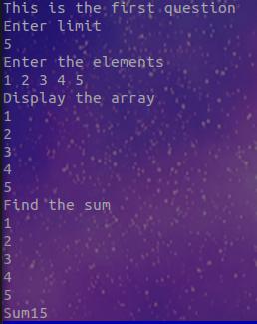

Practice Lab Assignment- II
Before the adding the method OddSum() to given code it is reading the size and inputs of the array and printing the inputs.
Snap of console :
a
void oddsum(){
int s=0;
for(int i=0;i<myList.length;i+=1) s+=myList[i]%2==1?myList[i]:0;
System.out.println("The odd sum of the array is:"+s);
}
public static void main(String[] args){
System.out.println("This is the second question:");
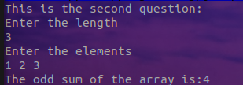
Scanner scan=new Scanner(System.in);
System.out.println("Enter the length");
int n=scan.nextInt();
q2 a=new q2(n);
a.oddsum();
}

Practice Lab Assignment- III

import java.util.Scanner;
class student {
int rollno;
String name;
int total_marks;
String grade;
student(int R, String S,int marks)
{
rollno=R;
name=S;
total_marks=marks;
}
void setData(int R,String S,int marks)
{
rollno=R;
name=S;
total_marks=marks;
}
void grading(student[] a){
for(student i:a){
if (i.total_marks>=90) i.grade="A+";
else if(i.total_marks>=80) i.grade="A";
else if(i.total_marks>=70) i.grade="B+";
else if(i.total_marks>=60) i.grade="B";
else i.grade="F";
}
}

void ShowData(student[] a)
{for(student i:a) System.out.println("Rollno:"+i.rollno+"\n"+"Name:"+i.name+"\n"+"Total marks"+i.total_marks+"\n"+"Maximum Marks:100"+"\n"+"Grade:"+i.grade);}
}
public class q3{
public static void main(String[] args){
Scanner scan=new Scanner(System.in);
student[] a=new student[3];
System.out.println("This is the 3rd question:");
for(int i=0;i<3;i++){
System.out.println("Enter the roll no:");
int rollno=scan.nextInt();
System.out.println("Enter the name:");
String name=scan.next();
System.out.println("Enter the total marks(max:100):");
int marks=scan.nextInt();
a[i]=new student(rollno,name,marks);
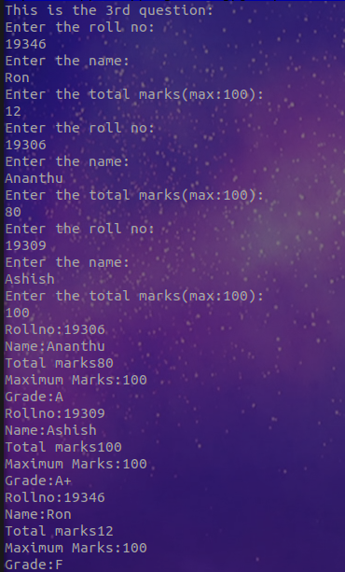
}
a[0].sort(a);
a[0].grading(a);
a[0].ShowData(a);
}
}

Practice Lab Assignment-IV

